Our Ref: _______________ Your Ref: ________________________ Date: __________________

Baptist Church

Baale Yaku Site Area, P. O. Box 644,

Ogbomoso, Oyo State. Tel. 07052425407

Email: [newsprinbaptistchurch@gmail.com](mailto:newsprinbaptistchurch@gmail.com)

Website: newspringbc.comze.com

NEW SPRING

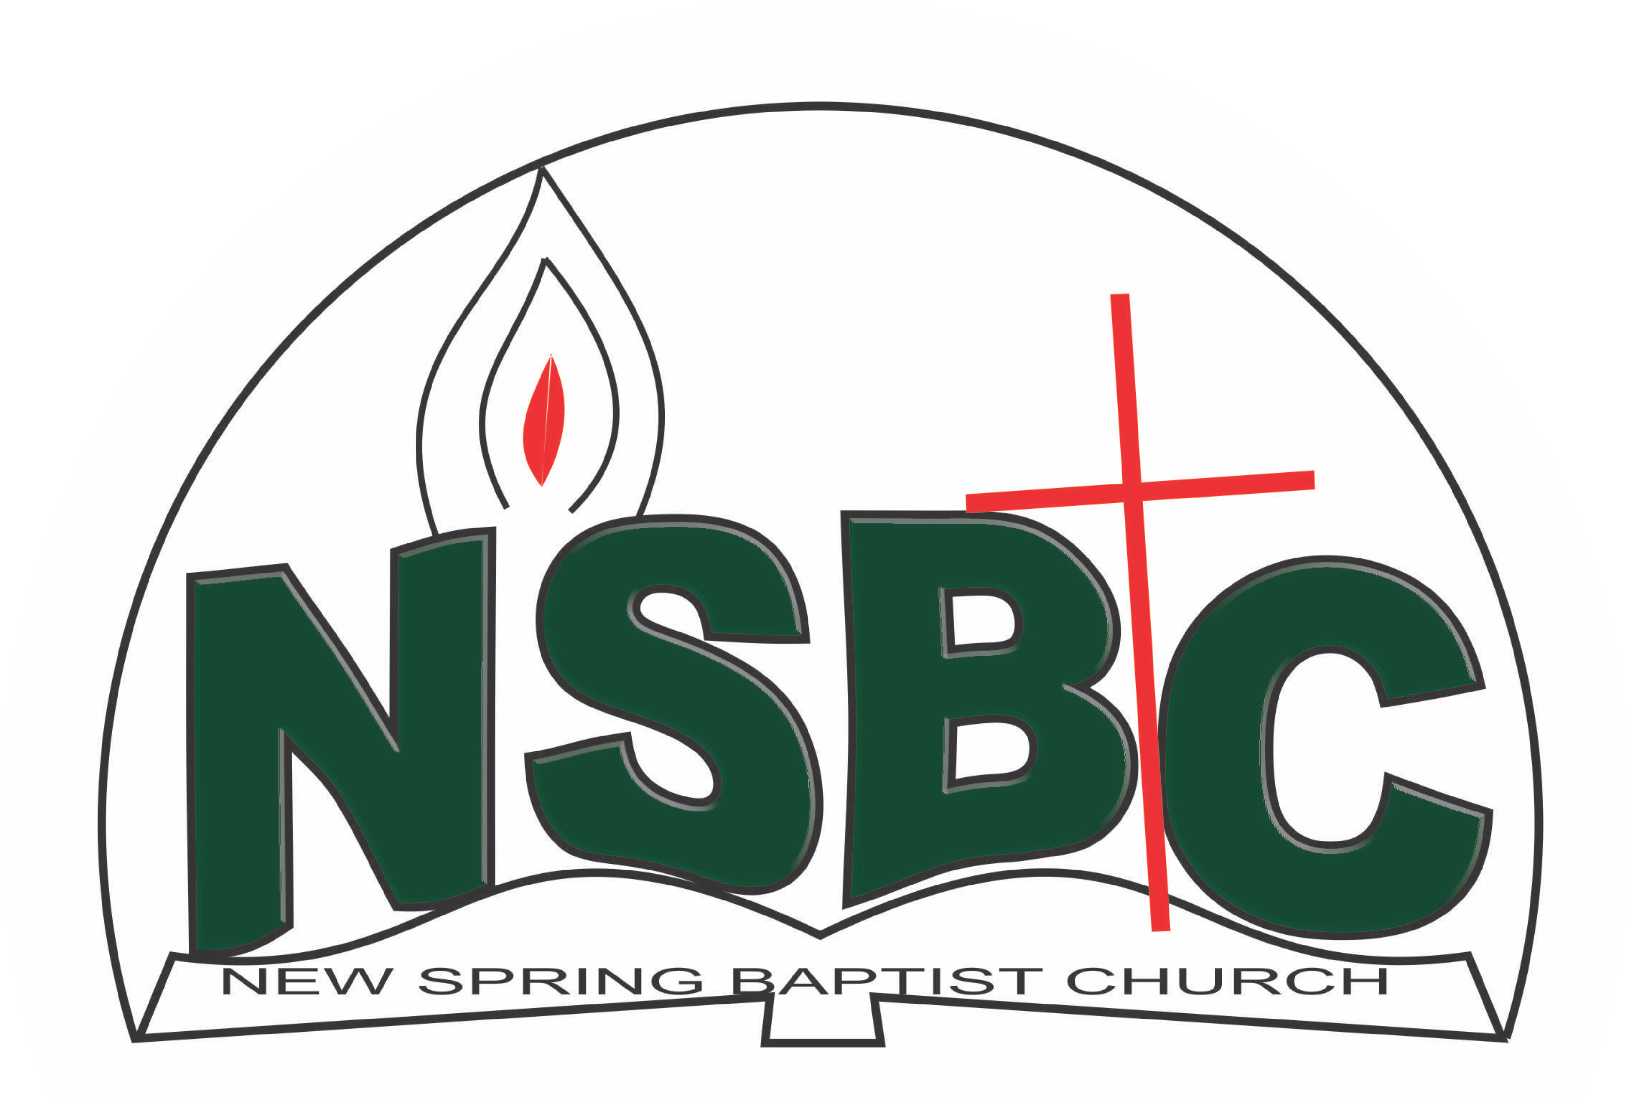

December 27, 2021

Dear Mrs. Alice Tudun Adeyi,

Nomination to Serve as a Worker in the Church in 2022.

Greetings in the precious name of our Lord and Saviour Jesus Christ. It is our pleasure to inform you that at the Church-in-Conference held on December 19, 2021, the Church ratified your nomination to serve in the following areas between January 1 and December 31, 2022:

1. Member, Ecumenical Affairs under the leadership of Mr.Bayo Babarinde

Please refer to the table below for the key functions of each of these roles. Details can be found in the Church constitution. You are strongly encouraged to become familiar with the tasks as stated in the document. There will be an orientation of the Church workers on January 15, 2022 at 8:30 a.m. on the church premises. Please ensure you participate in this training.

“Now it is required that those who have been given a trust must prove faithful. I Corinthians 4:2”. May God find you faithful in the task He has assigned to you.

| Domain | Key function of Office, Department or Committee |
| --- | --- |
| Ecumenical Affairs | To represent the Church and participate in the activities of umbrella organisations that the Church belongs to such as Christian Council of Nigeria, Bible Society |

Thank you for accepting to serve in this Church.

Yours in His service

Olusayo Okediji Blessed Agboola

Church Secretary Chairman, Nominating Committee